Being a UNESCO Global Geopark (UGGp) requires in the overall sense to follow the United Nations 2030 Agenda for Sustainable Development and its 17 Sustainable Development Goals (SDGs), since UNESCO is one of the specialized agencies of the United Nations.
The Global Geoparks Network through the GGN Working Group on SDG’s is compiling a Report that shows the evidence of the UNESCO Global Geoparks contribution to the SDGs.
For the UNESCO Global Geoparks it is essential to be perceived and mentioned as active partners in the implementation and promotion of the SDGs in UNESCO´s sessions, meetings and publications on a regular basis. This requires a scheme and continuity of reporting by the UNESCO Global Geoparks regarding all activities, which underline, how they support the SDGs.

The following SDG template, which has been conducted by the GGN Working Group on SDGs and updated after the GGN SDG Workshop (5th February 2024), is intended to collect the SDG information and data to fulfill this task. It combines the main information on each SDG with possible contributions of the UNESCO Global Geoparks, based on their tasks and activities.

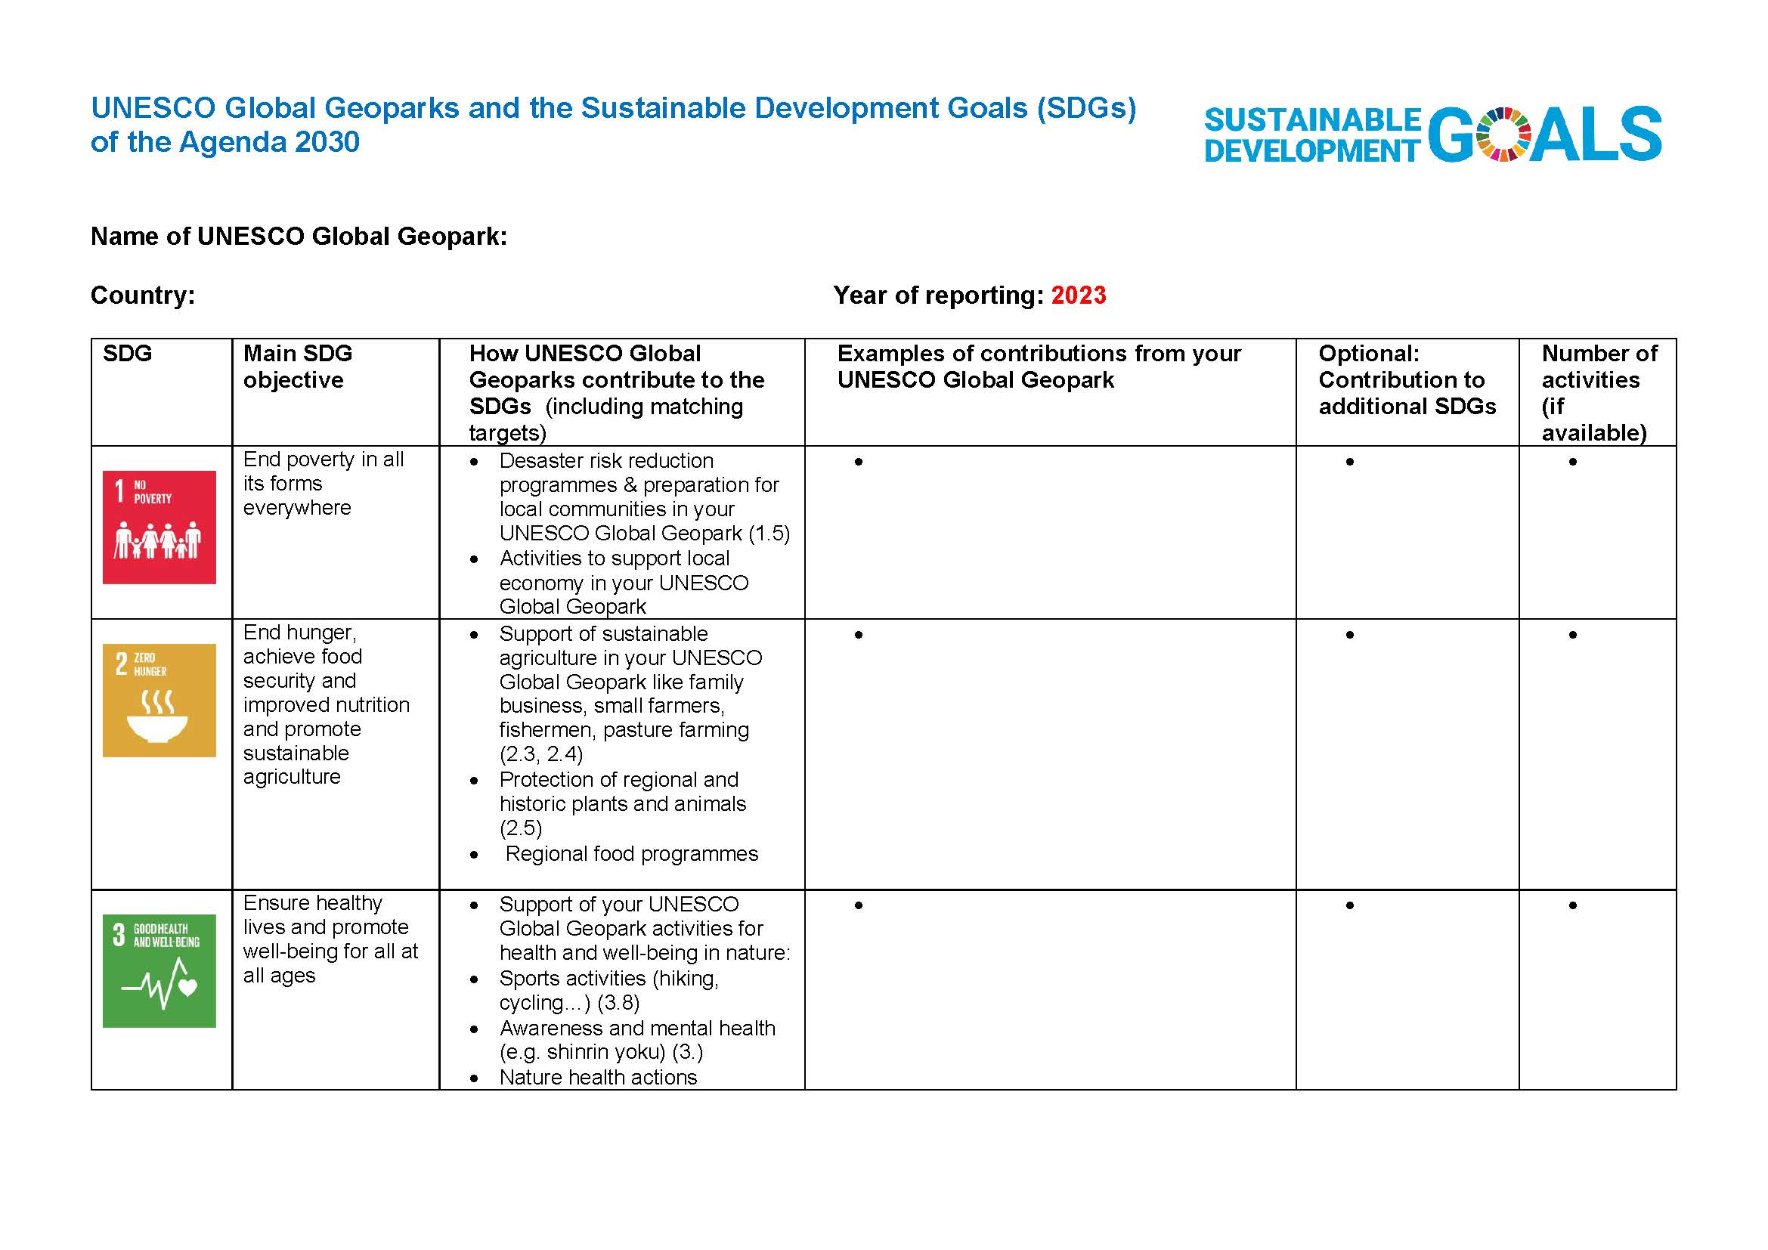
The template is composed by the following columns to be filled in with your respective information:

The SDG reporting starts from 2023 and will be continued on an annual basis. As Follow-up of the GGN SDG Workshop in February 2024, the GGN Regional Networks offer SDG Workshops to getting familiar with the SDG template and the reporting procedure.

In order to start the reporting process, we kindly ask you to complete the following template with your activities of the previous year 2023.

Please fillin the online template up to 30 March 2024.

In case you have no access to google please send your completed template up to the 30th March 2024 to secretariat@globalgeoparksnetwork.org

For any further questions, the GGN SDG Working Group offers a digital SDG tutorial on the 19th April 2024, 13:00-15:000 GMT.
An Invitation will be sent in time, through the GGN Secretariat.

Your SDG contributions will be collected to a comprehensive document, which underlines the role of UNESCO Global Geoparks as SDG Model Territories and creates awareness among UNESCO and its Member States about the importance of the IGGP to contribute to a sustainable future.

Template UNESCO Global Geoparks and the Sustainable Development Goals (SDGs) of the Agenda 2030

Name of UNESCO Global Geopark:
Country: Year of reporting: 2023
SDG | Main SDG objective | How UNESCO Global Geoparks contribute to the SDGs (including matching targets) | Examples of contributions from your UNESCO Global Geopark | Optional: Contribution to additional SDGs | Number of activities (if available)
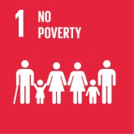 | End poverty in all its forms everywhere | - Desaster risk reduction programmes & preparation for local communities in your UNESCO Global Geopark (1.5)  - Activities to support local economy in your UNESCO Global Geopark
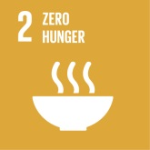 | End hunger, achieve food security and improved nutrition and promote sustainable agriculture | - Support of sustainable agriculture in your UNESCO Global Geopark like family business, small farmers, fishermen, pasture farming (2.3, 2.4)  - Protection of regional and historic plants and animals (2.5)  - Regional food programmes
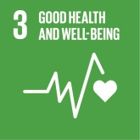 | Ensure healthy lives and promote well-being for all at all ages | - Support of your UNESCO Global Geopark activities for health and well-being in nature:  - Sports activities (hiking, cycling…) (3.8)  - Awareness and mental health (e.g. shinrin yoku) (3.)  - Nature health actions
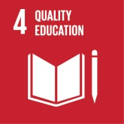 | Ensure inclusive and quality education for all and promote lifelong learning | - Your UNESCO Global Geopark educational programmes from kindergarden up to post-graduate level, as well as University students and programmes of lifelong learning (4.1, 4.2, 4.3)  - Education on Earth heritage and its links to natural and cultural heritage.  - Educative tools, trails and publications  - Education of the SDGs (4.7)  - Education of staff, guides & stakeholders  - Inclusive education for all (4.5)
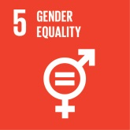 | Achieve gender equality and empower all women and girls | - Gender equality in your UNESCO Global Geopark management team  - Equal payment of male and female team members  - Female leading position in the team (5.5)  - Training courses for women empowerment  - Support of women cooperatives in the region  - Special offers for girls (e.g. Mountain Biking, MINT programmes)
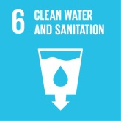 | Ensure access to water and sanitation for all | - Cooperation of your UNESCO Global Geopark with water companies  - Support of cleaning water activities & systems (6.3)  - Support of water-related ecosystems (e.g. in mountains, forests, rivers, lakes, groundwater) (6.6)
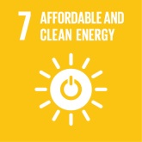 | Ensure access to affordable, reliable, sustainable and modern energy for all | - Use of sustainable energy in your UNESCO Global Geoaprk organisation  - Support of sustainable energy projects in your UNESCO Global Geopark communities  - Cooperation with innovative energy companies  - If available: E-drive team cars
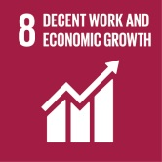 | Promote inclusive and sustainable economic growth, employment and decent work for all | - Cooperation with small local businesses in your UNESCO Global Geopark (8.4)  - Cooperation with tourism organisations & destinations (8.9)  - Provision of touristic infrastructure Geopark like trails, information panels , which can be used to develop offers.  - Cooperation with partners, which follow sustainable rules related employment and environment  - Cooperation with local action groups for regional sustainable development
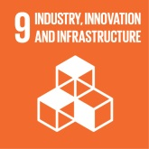 | Build resilient infrastructure, promote sustainable industrialization and foster innovation | - Cooperation with public transport in your UNESCO Global Geopark (9.1)  - Consideration of public transport options to reach trails and activities  - Implementation and restoration of trail and information facility infrastructure  - Infrastructure and offers for people with special needs  - Cooperation with research and sciences (9.5)  - Own research activities
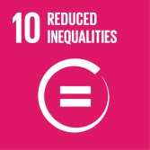 | Reduce inequality within and among countries | - Special UNESCO Global Geopark programmes for integration of refugees (10.7)  - Employment of foreign skilled workers
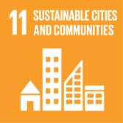 | Make cities inclusive, safe, resilient and sustainable | - Accessibility for all in your UNESCO Global Geopark facilities (e.g. trails, information centres, museums…) (11.7)  - Cooperation with UNESCO World Heritage Sites and other UNESCO programmes inside the UNESCO Global Geopark (11.4)
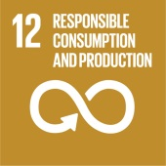 | Ensure sustainable consumption and production patterns | - Support of local producers and local products  - Programmes and activities with local farmers in your UNESCO Global Geopark (12.1, 12.2)  - Implementation of local markets with regional and seasonal products to create awareness to live in harmony with nature (12.8).  - Use of local and regional food for own Geopark activities, festivals and events  - Use of Geopark product criteria and label  - Support of waste prevention (12.5)
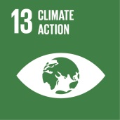 | Take urgent action to combat climate change and its impacts | - Activities of your UNESCO Global Geopark for climate protection:  - Tree planting, bog waterlogging, unsealing of soils / soil protection  - Climate protection awarenes rising campaigns (13.3)  - Campaigns to save CO2 (e.g. walking day, use of public transport..)  - Programmes for resilience against natural desasters and climate induced dangers (13.1)  - Compensation of CO2 consumption (e.g. plane travelling to conferences etc) either in Geopark territory or compensation programmes (e.g. atmosfair)
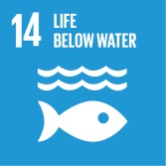 | Conserve and sustainably use the oceans, seas and marine resources | - Activities of your UNESCO Global Geopark to protect life under water  - Cooperation with institutions, which protect marine environment (14.4)  - Support of sustainable traditional and native fishing (14.7)  - Protection of marine biodiversity spots in UGGp  - Active waste prevention and cleaning actions (14.1)
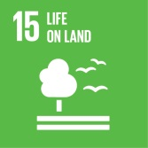 | Sustainably manage forests, combat desertification, halt and reverse land degradation, halt biodiversity loss | - Activities of your UNESCO Global Geopark to protect and restore ecosystems  - Protection of soil, prevent erosion, support biodiversity, preserve genetic resources awareness rising (15.1, 15.3, 15.6)  - Cooperation with forestry (e.g. planting activities with climate-resistant trees) (15.2)  - Activities to protect biodiversity (e.g. nesting houses, flowering areas, insect -friendly environment) (15.5)  - Protection of primary and secondary biotopes (often abandoned quarries)  - Protection and conservation of geosites and their geological & biological values  - Public gardening activities for local communities
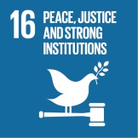 | Promote just, peaceful and inclusive societies | - Capacity building activities with your UNESCO Global Geopark communities and municipalities (16.7)  - Services and offers to strengthen the regional identity  - Regional networking and communication  - Promotion of the SDGs in the regional context  - Common projects for members and partners  - Cooperation across local and regional borders  - Cooperation with political decision makers  - Community participation following the “bottom up” approach  - Sound and transparent Geopark management with broad pareticipation of local communities (16.6)  - Cooperation with volunteers and stakeholders
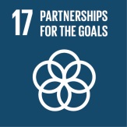 | Revitalize the global partnership for sustainable development | - Information on the SDGs in your UNESCO Global Geopark (e.g. website, social media, magazines, brochures, workshops, campaigns)  - Your contributions to international networking of the UNESCO Global Geoparks via GGN (17.6)  - Your participation in common projects and activities of the UNESCO Global Geoparks and respective regional networks (e.g. workshops, courses, media, publications, UN days)  - Active cooperation between UNESCO Global Geoparks inside countries and across the continents by common projects (17.16, 17.17)  - Your contributions to capacity building and consultancy for potential UNESCO Global Geopark candidates (17.9)  - International networking between different UNESCO programmes by common projects (17.6)  - Promotion of the SDGs in the international context and publication of best practice (e.g. at conferences)

SDG information source: http://www.un.org/sustainabledevelopment/sustainable-development-goals/

Please send your completed template up to the 30th March 2024 to secretariat@globalgeoparksnetwork.org

