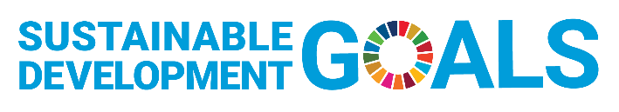
UNESCO Global Geoparks and the Sustainable Development Goals (SDGs)
of the Agenda 2030

Name of UNESCO Global Geopark:
Country:
SDG | Main SDG objective | How UNESCO Global Geoparks contribute to the SDGs | Examples of contributions from your UNESCO Global Geopark | Intensity of your contribution    (1 – 3) | Number of participants (if available)
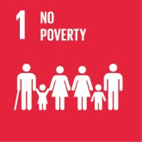 | End poverty in all its forms everywhere | - Desaster risk reduction programmes & preparation for local communities in your UNESCO Global Geopark  - Activities to support local economy in your UNESCO Global Geopark
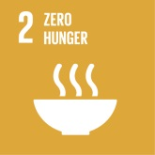 | End hunger, achieve food security and improved nutrition and promote sustainable agriculture | - Support of sustainable agriculture in your UNESCO Global Geopark like family business, small farmers, fishermen, pasture farming  - Protection of regional and historic plants and animals  - Regional food programmes
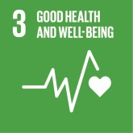 | Ensure healthy lives and promote well-being for all at all ages | - Support of your UNESCO Global Geopark activities for health and well-being in nature:  - Sports activities (hiking, cycling…)  - Awareness and mental health (e.g. shinrin yoku)  - Nature health actions
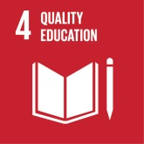 | Ensure inclusive and quality education for all and promote lifelong learning | - Your UNESCO Global Geoaprk educational programmes from kindergarden up to post-graduate level, as well as University students and programmes of lifelong learning  - Education on Earth heritage and its links to natural and cultural heritage.  - Educative tools, trails and publications  - Education of the SDGs  - Education of staff, guides & stakeholders  - Inclusive education for all
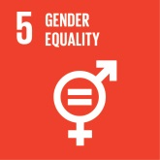 | Achieve gender equality and empower all women and girls | - Gender equality in your UNESCO Global Geopark management team  - Equal payment of male and female team members  - Female leading position in the team  - Training courses for women empowerment  - Support of women cooperatives in the region  - Special offers for girls (e.g. Mountain Biking, MINT programmes)
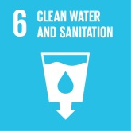 | Ensure access to water and sanitation for all | - Cooperation of your UNESCO Global Geopark with water companies  - Support of cleaning water activities & systems  - Support of water-related ecosystems (e.g. in mountains, forests, rivers, lakes, groundwater)
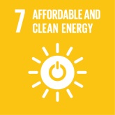 | Ensure access to affordable, reliable, sustainable and modern energy for all | - Use of sustainable energy in your UNESCO Global Geoaprk organisation  - Support of sustainable energy projects in your UNESCO Global Geopark communities  - Cooperation with innovative energy companies  - If available: E-drive team cars
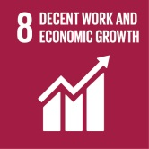 | Promote inclusive and sustainable economic growth, employment and decent work for all | - Cooperation with local businesses in your UNESCO Global Geopark  - Cooperation with tourism organisations & destinations  - Provision of touristic infrastructure Geopark like trails, information anels , which can be used to develop offers.  - Cooperation with partners, which follow sustainable rules related employment and environment  - Cooperation with local action groups for regional sustainable development
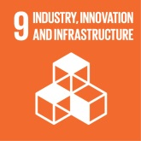 | Build resilient infrastructure, promote sustainable industrialization and foster innovation | - Cooperation with public transport in your UNESCO Global Geopark  - Consideration of public transport options to reach trails and activities  - Implementation and restoration of trail and information facility infrastructure  - Infrastructure and offers for people with special needs  - Cooperation with research and sciences  - Own research activities
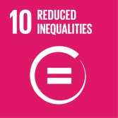 | Reduce inequality within and among countries | - Special UNESCO Global Geopark programmes for integration of refugees  - Employment of foreign skilled workers
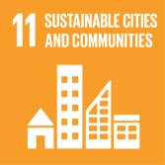 | Make cities inclusive, safe, resilient and sustainable | - Accessibility for all in your UNESCO Global Geopark facilities (e.g. trails, information centres, museums…)  - Cooperation with UNESCO World Heritage Sites and other UNESCO programmes inside the UNESCO Global Geopark
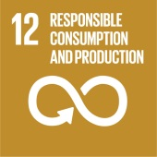 | Ensure sustainable consumption and production patterns | - Support of local producers and local products  - Programmes and activities with local farmers in your UNESCO Global Geopark  - Implementation of local markets with regional and seasonal products.  - Use of local and regional food for own Geopark activities, festivals and events  - Use of Geopark product criteria and label  - Support of waste prevention
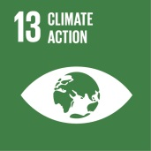 | Take urgent action to combat climate change and its impacts | - Activities of your UNESCO Global Geopark for climate protection:  - Tree planting, bog waterlogging, unsealing of soils / soil protection  - Campaigns to save CO2 (e.g. walking day, use of public transport..)  - Programmes for resilience against natural desasters and climate induced dangers  - Compensation of CO2 consumption (e.g. plane travelling to conferences etc) either in Geopark territory or compensation programmes (e.g. atmosfair)
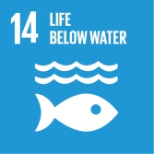 | Conserve and sustainably use the oceans, seas and marine resources | - Activities of your UNESCO Global Geopark to protect life under water  - Cooperation with institutions, which protect marine  - Support of sustainable traditional and native fishing  - Protection of marine biodiversity spots in UGGp  - Active waste prevention and cleaning actions
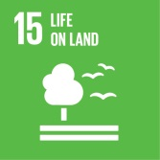 | Sustainably manage forests, combat desertification, halt and reverse land degradation, halt biodiversity loss | - Activities of your UNESCO Global Geopark to protect soil, prevent erosion, support biodiversity, preserve genetic resources  - Cooperation with forestry (e.g. planting activities with climate-resistant trees)  - Activities to protect biodiversity (e.g. nesting houses, flowering areas, insect -friendly environment)  - Protection of primary and secondary biotopes (often abandoned quarries)  - Protection and conservation of geosites and their geological & biological values  - Public gardening activities for local communities
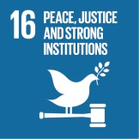 | Promote just, peaceful and inclusive societies | - Capacity building activities with your UNESCO Global Geopark communities and municipalities  - Services and offers to strengthen the regional identity  - Regional networking and communication  - Promotion of the SDGs in the regional context  - Common projects for members and partners  - Cooperation across local and regional borders  - Cooperation with political decision makers  - Community participation following the “bottom up” approach  - Sound and transparent Geopark management  - Cooperation with volunteers and stakeholders
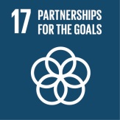 | Revitalize the global partnership for sustainable development | - Information on the SDGs in your UNESCO Global Geopark (e.g. website, social media, magazines, brochures, workshops, campaigns)  - Your contributions to international networking of the UNESCO Global Geoparks via GGN  - Your participation in common projects and activities of the UNESCO Global Geoparks and respective regional networks (e.g. workshops, courses, media, publications, UN days)  - Active cooperation between UNESCO Global Geoparks inside countries and across the continents by common projects  - Your contributions to capacity building and consultancy for potential UNESCO Global Geopark candidates  - International networking between different UNESCO programmes by common projects  - Promotion of the SDGs in the international context and publication of best practice (e.g. at conferences)

SDG information source: http://www.un.org/sustainabledevelopment/sustainable-development-goals/

Level of intensity of your UNESCO Global Geopark contribution to respective SDG

High intensity
Moderate intensity
Low intensity

