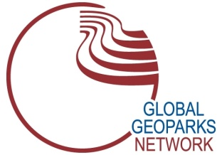 | GLOBAL GEOPARKS NETWORK  International Association on Geoparks  www.globalgeoparksnetwork.org

GGN Executive Board Candidature Form

This is a candidature form for the Global Geoparks Network Executive Board Candidature Position (Member, President, Vice-President, Treasurer, General Secretary).
Dead line for submissions: October 11th, 2021 at 24:00 GMT.

Candidate

Name and Surname

GGN Member Number

Institutional/Individual

Executive Board seat

Structure proposing the candidature (choose which one of the three)

GGN Regional Network

GGN National Forum
Global Geoparks | .

Candidate’s Personal information

First name

Last name

Title / Professional position

UNESCO Global Geopark Representative or GGN Individual Member

e-mail
Telephone (Please include dialing code)
Mobile

Address

Post code

Country

By signing this document I confirm that:
- I have taken note of and will respect the Statutes of the Global Geoparks Network (GGN), the GGN Code of Ethics and the GGN Internal Rules and Regulations, in my capacity as member of the Global Geoparks Network Executive Board.

- I do not have any kind of conflict of interest related to the mandate and duties of being member of the Global Geoparks Network Executive Board.

Place and Date:

Signature:

Annex 1. CV

